Cashless Economy:

A Boon or Bane?

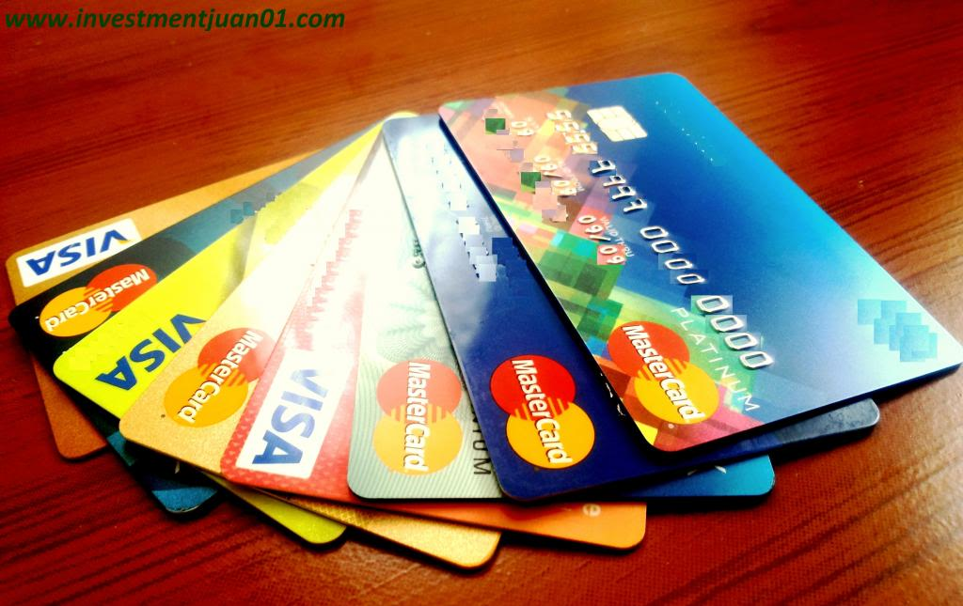The **boon** of this system has been progressively increasing the online transactions for payments processing banks and companies by about three times more to what they were before demonetization. The government can see a healthy growth of more than 20 percent on a month on month basis in transactions on online payment gateway like debit, credit cards, net banking, mobile banking, e-wallets, point-of-sales, coupons, pre-paid cards etc. Credit, debit cards and such other forms also called as “**plastic money**”. Highly ethical change has been the curb on black money and illegal transactions of money.

<https://www.google.com/imgres?imgurl=https%3A%2F%2Fm.economictimes.com%2Fthumb%2Fmsid-64230667%2Cwidth-1200%2Cheight-900%2Cresizemode-4%2Cimgsize-28918%2Fmobile-transaction-thinksto.jpg&imgrefurl=https%3A%2F%2Fm.economictimes.com%2Fwealth%2Finvest%2Fhow-to-do-mutual-fund-transactions-using-upi%2Farticleshow%2F64230685.cms&tbnid=w7PkOK0uAKeLAM&vet=12ahUKEwjRv-aSvqTqAhUv1XMBHWzXC_gQMygAegUIARCuAQ..i&docid=23bZRqsxzJxknM&w=1200&h=900&q=phone%20with%20online%20transcation&client=firefox-b-d&ved=2ahUKEwjRv-aSvqTqAhUv1XMBHWzXC_gQMygAegUIARCuAQ>

A form of Plastic Money ‘**Credit Cards**’

The biggest **bane** of the cashless economy is that not everybody has the knowledge of doing digital transactions and hence its reach is limited to urban and semi-urban centers only and therefore it is very difficult to implement cashless economy in a big country like India where many sections of the society in rural.

Submitted by:- Aniket Dixit IX-A, Sunder Deep World School